Protecting Your Family
The Importance Of A Radon-Resistant Home Greener Living=Healthier Indoor Air

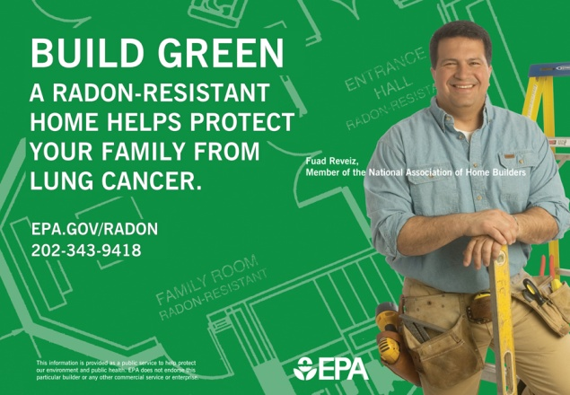
(NAPS) — If you want to live a more sustainable life and protect your family from cancer, learn about one of the home’s most dangerous pollutants: radon. Radon is a cancer-causing natural radioactive gas that you can’t see or smell. It’s the leading cause of lung cancer among nonsmokers and claims about 20,000 lives every year.
The indoor air quality of your home can affect your family’s health.

Although some lung cancers can be treated, the survival rate is one of the lowest for those with cancer. Fortunately, many of the causes of lung cancer can be prevented– and this is especially true for radon.

The Office of the Surgeon General has issued a health advisory warning Americans about the risk from breathing radon in indoor air. Americans are urged to test their homes to find out how much radon they might be breathing.

Radon comes from the natural (radioactive) breakdown of uranium in soil, rock and water and gets into the air you breathe. Radon can be found all over the U.S. It can get into any type of building– homes, offices and schools– and can climb to high levels if it’s trapped indoors.

For most Americans, the greatest exposure to radon is in their homes, whether those homes are old or new. Any home, any type, any location can have a radon problem. If your home has not been tested, now is a good time to take the test. This will help protect your family’s health and it’s easy to do.

The U.S. Environmental Protection Agency (EPA) recommends homes be fixed if the radon level is 4 picocuries per liter of air (4pCi/L) or above. While testing can be easy and inexpensive, millions of Americans have yet to take this first important step to protect their family.

The indoor air quality of your home can affect your family’s health. You can test your home yourself or hire a qualified radon measurement professional. Reliable do-it-yourself testing devices can be purchased in hardware and home improvement stores or online.

Fixing a radon problem is easy too– and doesn’t have to be costly. Radon reduction systems can lower radon to a safer level indoors.

“It’s inexpensive to build a new home with radon-resistant features. A better home will be both greener for the planet and healthier for your family,” said Fuad Reveiz, a member of the National Association of Home Builders.

For help in identifying radon test kit manufacturers and laboratories, call your state radon office or visit www.epa.gov/iaq/whereyoulive.html.

For more information, call 1-800-SOS-RADON (1-800-767-7236) or visit www.epa.gov/radon.

